Maze 2015

Introduction
The major project for this semester is creating a maze and solving it in Python. We will use test driven development techniques. We will be using the JES framework. As you follow through this tutorial, make sure you do the typing and understand what it is you are entering. If you have questions, contact me.

Starting out
To begin, we want to write our first test. We will start simply with basic concepts. Normally some of these steps would not be made but we are trying to approach this from inexperience. As you get more experienced, you will learn which steps to skip. Create a file called maze.py and put your name and a description of the program as follows:
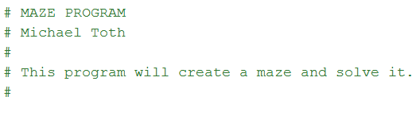 Of course you put your own name in place of mine. Since we won’t want to always run our tests and we don’t have a testing framework that operates properly in JES, we will put our own tests into the same file as our program and qualify them with an ‘if’ statement so we can turn them off if we want to. Add this to the bottom of your file.
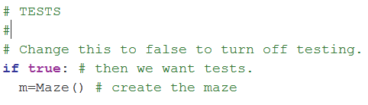When you load this file now you should see an error. (RED CONDITION)
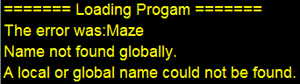 Now we need to create the Maze class. Do this above your tests.
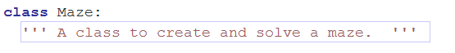When you load the file now you should see no errors. (GREEN)
You have just take the first step in a test driven development project. You went from RED to GREEN. Now we want to add another test. Our maze must be able to be shown or displayed on the screen. A natural method to do this might be called ‘draw’. Let’s check that we have a ‘draw’ method in our class.
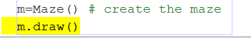 When you add this to your tests, you should see the error (RED CONDITION)
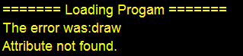 Now add the draw method. It doesn’t need to do anything.
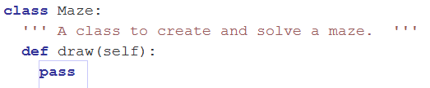You should now be able to load without error. Notice that we are not actually writing ‘tests’ in the sense that we are checking for values, we are just watching exceptions occur as we add lines to our testing area. Normally we will use assertions to check for particular aspects of these objects. That will come in time as we add to our class.
Next we want to make sure when we create a maze, we have nothing but walls except for where we are located in the maze. So we should have a totally blue square with one small white square representing our starting location. But before we can deal with that, we need to have an image to work with in the maze class. We want this image to exist from the beginning when we create our maze so in the __init__ method we will use makeEmptyPicture() which is supplied by JES. Write a test to see if we have an image in the class.
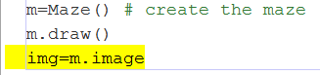You should see the error 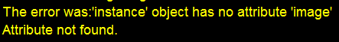
since we don’t have an image created yet. Now add the __init__ method which will create the image and while we are at it, let’s add a width and height property to the maze.
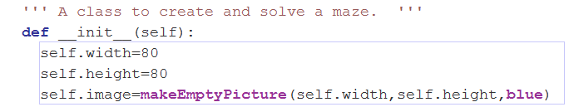 Now you should no longer see the error.
Some aspects of test driven development do not easily lend themselves to user interface or GUI behavior. For instance, if you want to verify that the image is actually displayed on the screen when you invoke draw() you need to just look rather than automate that. Right now, nothing happens when you call draw(). So now add the code to make sure you see the image when you invoke draw(). We will use repaint() rather than show() because show() creates a new window each time you use it. After a while we will be up to our elbows in windows if we don’t stop that.
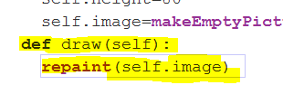 Luckily repaint() will work properly even if the image has not yet been shown. Now when you load the file, you should see the image. 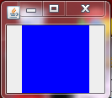 It’s a good thing we put that test in which draws the image. We can immediately see this is too small! We will never be able to work with a maze this small. Our maze will be constructed of small blocks rather than pixels so we need to adjust the size accordingly.
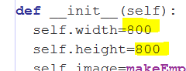 Now we have a reasonably sized maze image suitable for an 80x80 grid of 10x10 squares.
We are currently in the GREEN state but now it might be useful to do a little refactoring. We have hard numbers for the size and we may want to generalize that in the future for different sized mazes and also we may want to use the dimensions later in our work, so let’s define some values for these.
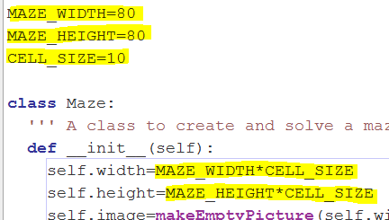 When you load the file you should still see no errors. The important part of refactoring is verifying that you have not broken any of the existing tests and you stay in the GREEN state until you write your next test. Our next test will be to see if we have the white square in our ‘home’ location. Let’s call the home location (1,1) corresponding to the upper left hand corner of the maze. We will not start at 0,0 because our boundary cells are going to be treated differently than the rest. This way we don’t have to worry about going out of bounds in our maze. Location 1,1 corresponds to one column over and one row down. Checking the color at pixel CELL_SIZE,CELL_SIZE should do it. Add this to your tests.
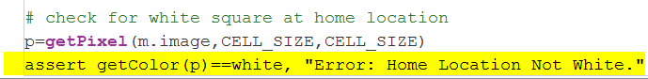 Notice we put the message in to let us know what the problem is. Now when you load the program, you should see this.
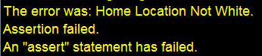 We knew this would fail since we created an all blue image. Let’s make this test pass by putting the white square in during initialization. Add this code to your __init__ method.
Now you should see no errors. Not much of a maze yet of course. What’s the next step? Much of this is where the art of programming comes in. You need to make a choice about what you want to look for. We know we want to first create a maze. To do this we might have the idea of ‘digging’ in the blue area and making a white path. We need a way to represent the architecture of the maze. Up until now we have only made an image. Let’s represent our maze as a matrix. Each entry in the matrix will correspond to one cell in the maze. The dimensions of the matrix will be MAZE_WIDTH x MAZE_HEIGHT. You can create a matrix with one line of Python. The values in each of the matrix cells corresponds to the cell being either empty, or visited, or a wall, or revisited. We will choose values to represent these different states. The value 0 will be an empty cell and the value 1 will be a wall. We will call this matrix ‘matrix’! Check to see if matrix exists and cell 1,1 is empty.
We should now be in the RED condition.
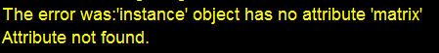 Maybe not the result you expected since we didn’t yet create the matrix. Let’s do that in the initialization (__init__) method.
Now we are back to GREEN. Time to refactor. It’s not nice to use 1 for wall and 0 for empty because you have to remember 1 is wall and 0 is empty. Let’s define our states so we can just remember them by name. Add this above your Maze class definition.
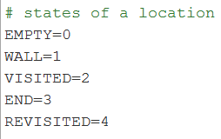 Now we can just use the names directly instead of values. Use this in place of the values you just entered. (Note: it’s common but not essential to use capital letters when defining constant values.)
Verify you are in the GREEN condition.
We don’t have anything yet telling us where we are in the maze. We will call it ‘location’ and it will be a duple of x and y values for the current location in the maze. Initially of course it should be (1,1).
Notice your error now.
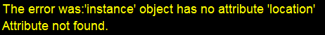 You should be familiar with this one by now. Let’s add the code to the __init__ method.
Now your tests should pass.
We want to be able to dig a path through the walls. Let’s make a method called dig. Dig will take an argument for a direction and will return True if it was successful. To be successful you have to dig into a wall. You don’t want to think you have successfully dug in a given direction if it is already empty or if it is at the boundary. You only want to think you successfully dug if there was a wall which is now replaced by an empty state. Now we need to determine how to represent the four directions; up, down, left, and right. Let’s say up=0, down=1, left=2, and right=3. We will do the same thing we did for the states of a cell. Let’s define the directions so we don’t have to remember them.
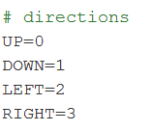Put this code just below the states you defined earlier.
Now test for the dig method.
This should give you the usual “Attribute not found” error.
Add the dig method to your Maze class. 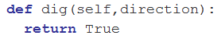and you should be in the GREEN condition again. But dig does nothing! That’s ok. We just first wanted to make it exist. Now the next test will be to see if it actually worked. We check for that by testing the color at 20,10.
Notice we use our constant for cell size. Your error should be 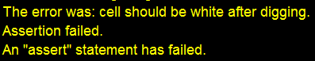. Now add the code to make it pass.
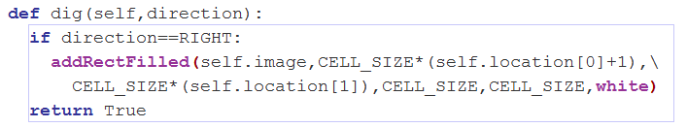 Notice that we only worry about the RIGHT direction because we write the minimum amount of code needed to make the test pass. We use our location as a guide as well as our constants that we defined earlier. You should now be in the GREEN condition.
Next we verify that the matrix also reflects the state of that cell properly.
This puts you back in the RED state.
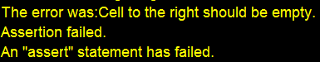 Make this pass by adding the code to the dig method.
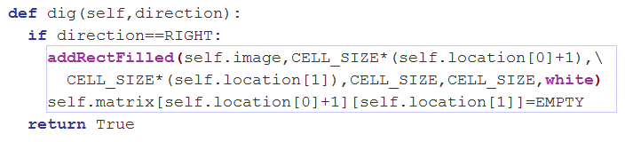 and you are back to GREEN.
The other 3 directions are done in the same way. I will not include that in this tutorial. You can do it yourself. Add them now so you can continue with the tutorial because there are some differences we will deal with in the ‘left’ and ‘up’ directions.
This is what your tests should look like.
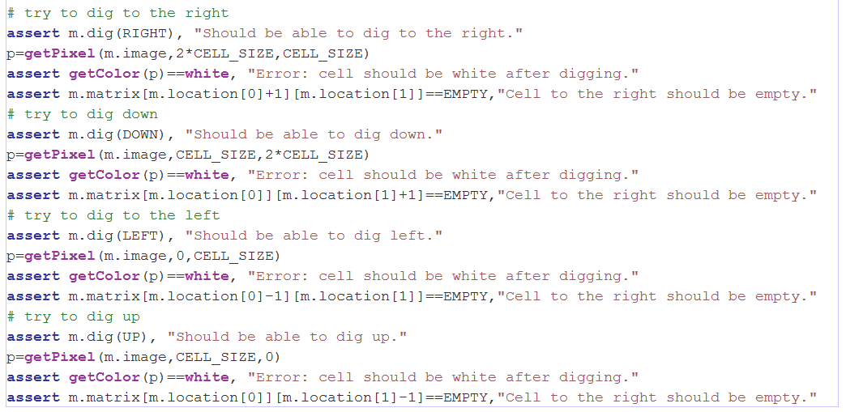
This is just the start for our tests for digging. Notice that from our starting location, (1,1), we should not be able to dig left or up. This would dig into the boundary which we want to keep out-of-bounds and always a wall. So we want to change these two tests for those directions.
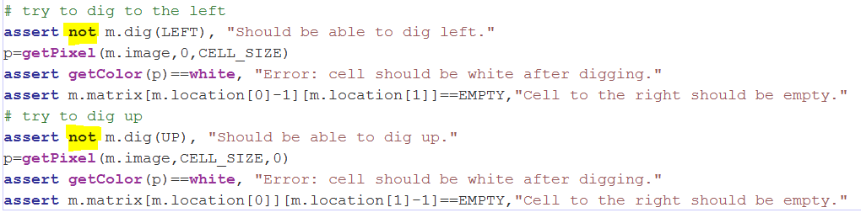
These should fail now. We need to put a check so we return False if we hit the boundary. Let’s create the coordinates we want to dig to for convenience so we can check this. After refactoring, the method should look like this.
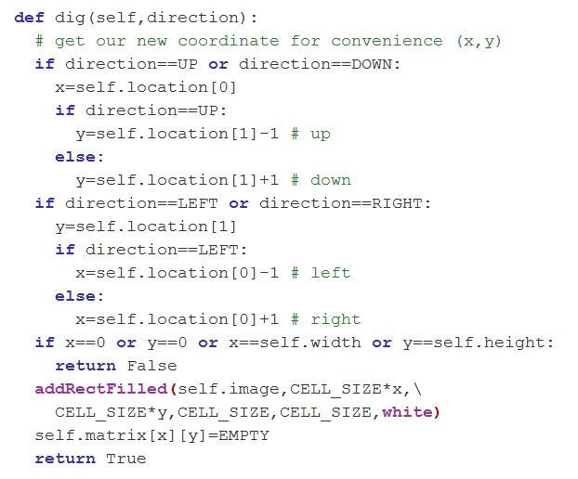 This refactoring is a bigger step than usual. Take time to understand how we simplified this method by pre-computing the new coordinates x and y. We still have some failures in our tests however.
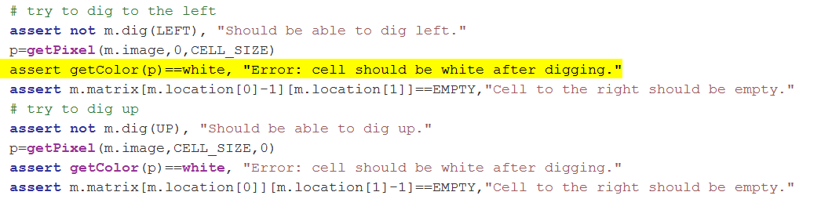
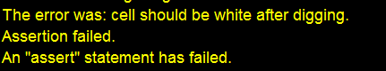 We fixed the image color but not the matrix cell state. Fix that now.
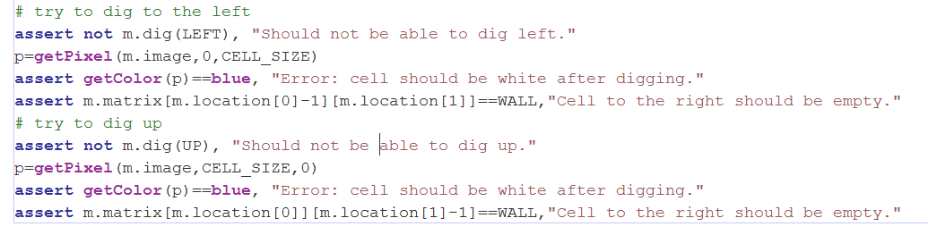 Now you should be in the GREEN state.
We need to test the other two boundaries to be complete. Add those tests.
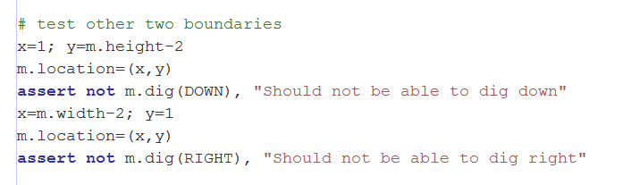 You should still be in the GREEN state. If not, check your code to see what went wrong.
Now that we can dig, we want to be able to move into the space we dug.
We are starting to make several changes to the image and to the matrix. For further testing it is useful to create a reset method to make things go back to the initial state.
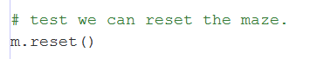This of course gives us our old “Attribute not found” friend. Create the method.
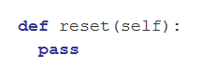 Now write better tests for reset.
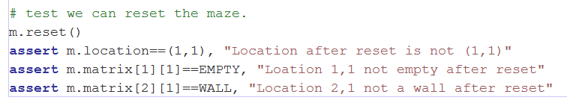
Notice they don’t pass since we don’t do anything for reset yet. Also notice that what we want to do is already done in __init__ so let’s just move that code to reset() and call reset() from __init__
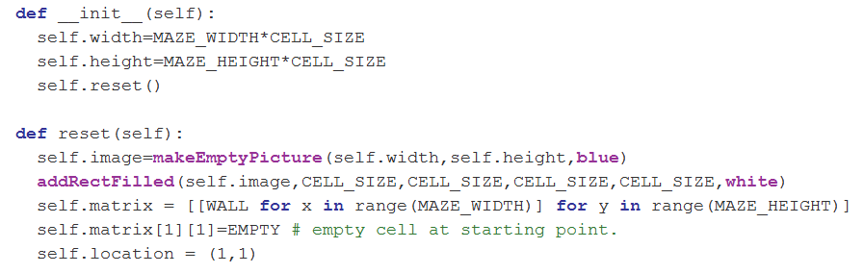We combined the coding with the refactoring in this step to save time.
You should now be in the GREEN condition. Now we want to test for moving after we dig.
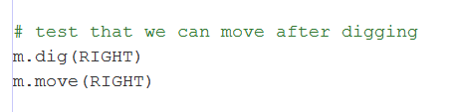Add this test and say hello to your old “Attribute not found” friend.
Add the move method. 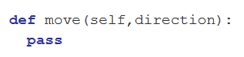to make the tests pass.
Modify the tests so we can verify we actually did move! 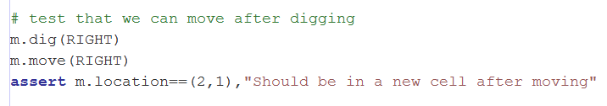
Check your tests. 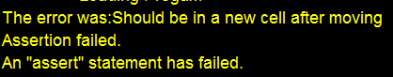 Now add to the move method to make the test pass.
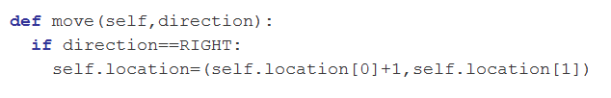Now your test should pass. We need to verify that we have moved or not however. Right now we don’t return anything from move(). Let’s change that. Test that when we have a successful move, we get the new coordinate returned. If we haven’t moved, we get the same one we started with returned.
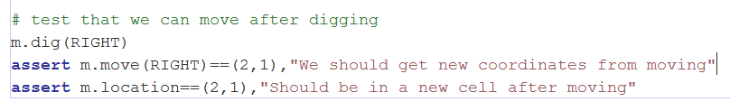 But we don’t
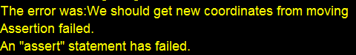 Fix this.
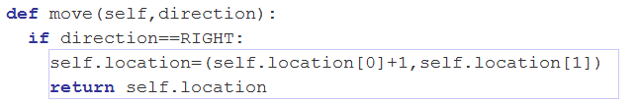 Now in GREEN state.
We can’t move into a wall so verify we get the same location if we try to move after a reset.
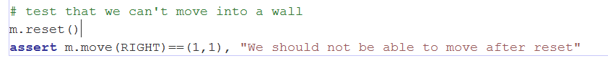This will fail.
Fix it.
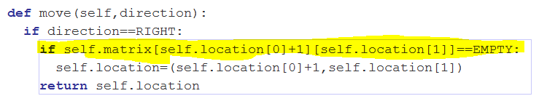Now in GREEN state.
Like before, we need to deal with the other 3 directions. Here are the tests.
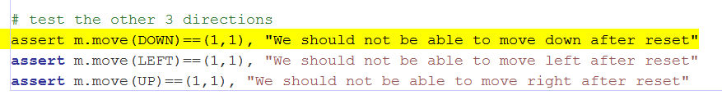Fixing this gives us the following code.
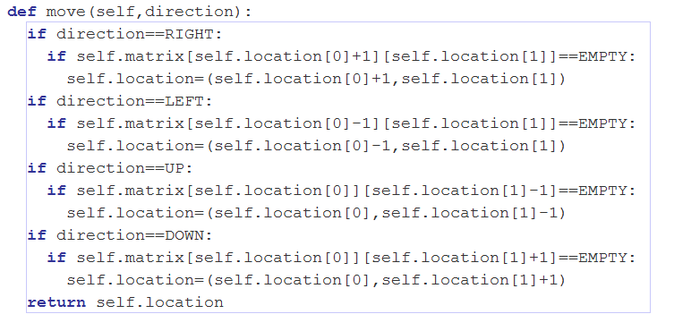Now in GREEN state.
Now we can dig and move. We are getting close to making a path for our maze. We want the path to be somewhat random so it’s not a trivial maze. We will use the random module for that purpose. The path starts at (1,1) and ends at either the right-hand border or the lower border.

Let’s start by trying to dig to the right-hand border.
Our test is 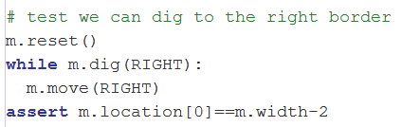because dig() should return False when we hit the border, we should be adjacent to the border when we stop. Instead we get the error 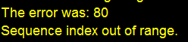 which occurs in our dig routine. 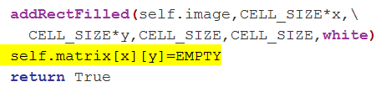 so x is getting to 80 when the largest value it can have is 79. Why is that?
When our x location is 78, and we call dig, we should return False because we don’t want to dig into column number 79. We have a test for this though. Remember this test? 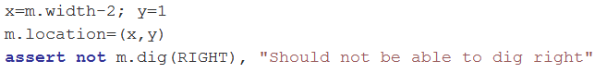
This passes because we set x to be m.width-2 but our thinking was not correct. m.width is really 800! Fix this test and the test above it.
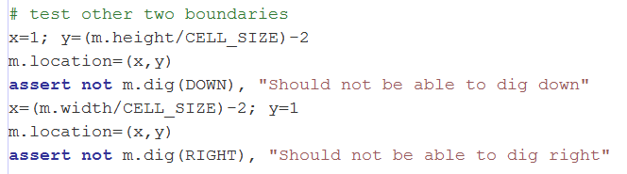Now these tests should fail. We fix the code as follows.
Change the dig method to use the following
and change our tests to be as follows.
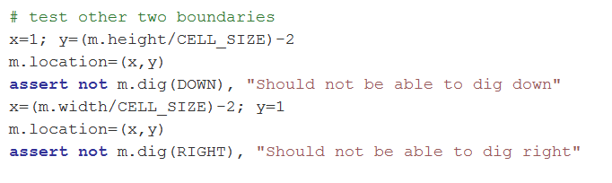and
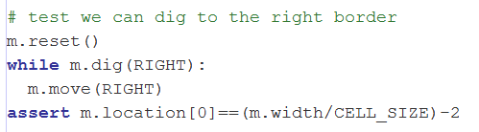
Now your tests should pass. GREEN!
Problems like this get caught early when using test driven development.
Just for completeness, let’s do the same thing going down to the lower border.
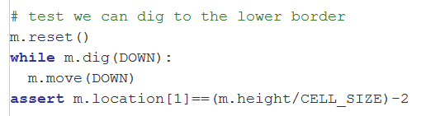 It should pass right away.
Now lets make a method called create_path() which zig-zags randomly to the right and down until it hits a border. First the test of course!
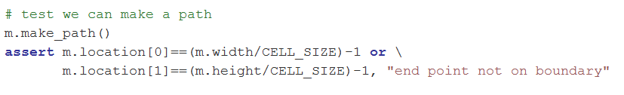 RED CONDITION
Now the code. (Don’t forget to import random at the top of the file)
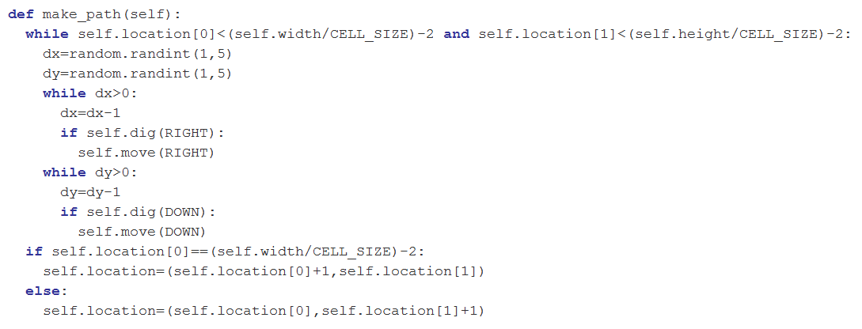GREEN CONDITION!

If you look at the result, you should see something like this.
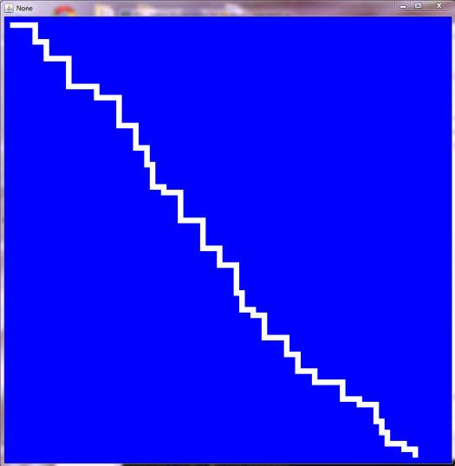 Certainly not much of a maze yet but we are making progress. Seems to me the path lengths should be a bit longer. Let’s increase the random limit to 15 rather than 5 and make the minimum length 5.
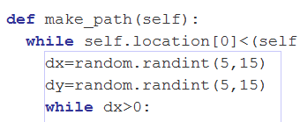With this change, our make_path method gives us something like this.
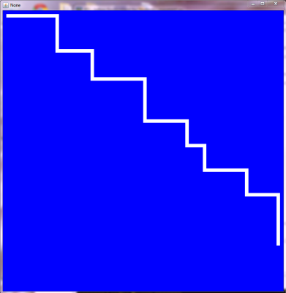 This is looking better.
Now we want a pot of gold at the end of our maze. Let’s put a yellow square at the end.
Testing 1,2,3…
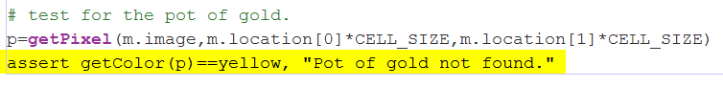Remember after make_path is called, one of our coordinates is placed on the border. This is the final location. It should be yellow. It’s not. Make it so! Put this at the end of make_path()
GREEN!
Not only do we have the color to check, but also the matrix value should be END for that location.
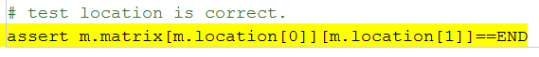 RED!
Fix this by adding this line at the end of make_path().
GREEN!
Here’s how it looks.
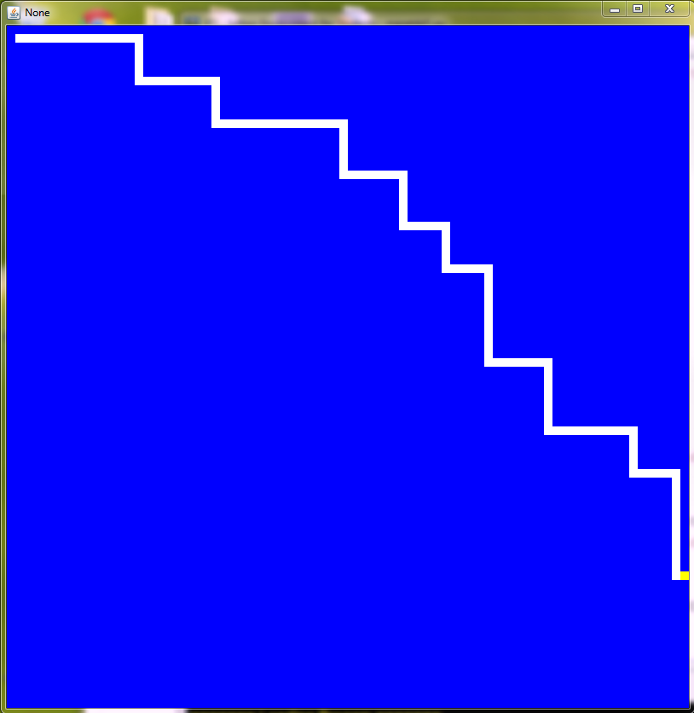 Notice the pot of gold.
The last thing to do is fill in the rest of the maze with false paths. Since we only want one pot of gold. Let’s add an argument to make_path so that can be turned off. Change make_path. 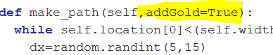
Now when we don’t pass in that argument it is assumed to be True. When we fill in the rest of the maze, we will set it to be False. For it to be useful, we need to use it inside the method. Qualify the last two lines of make_path with the if statement as follows.
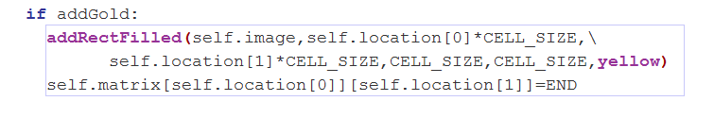Everything should still work as before. GREEN!

Filling in the rest of the Maze
To fill in the rest of the maze, we can use recursion. Imagine taking one of the turns in the path and digging from there. Just dig one path part way in, then repeat the process after that until you can't do it anymore. That kind of problem lends itself to recursion nicely.
The algorithm we will try to implement will be as follows:
    - go to the first turn in the path to the gold.
    - If you can dig in any direction from this point, dig in that direction for a random length or when you can't dig any more, whichever is smaller.
    - At the point which you stop, repeat step 2 until you can't dig in any direction
    - go to the next turn in the path to the gold.
    - If you have reached the gold, stop. Otherwise go back to step 2.
Let's write our first test. The test to see that we can go to the first turn in the path to the gold.
Let’s test for this by making a simple right hand turn and see if we get there.
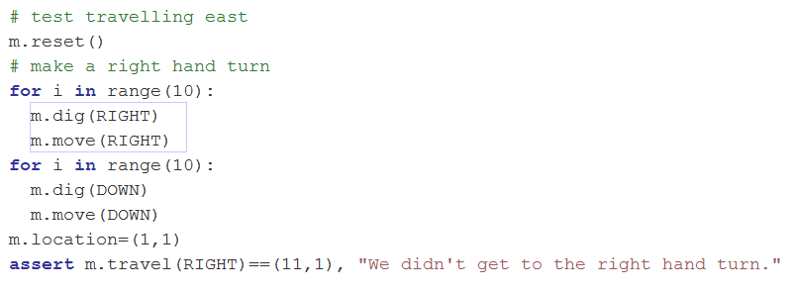I’m skipping the error that the method doesn’t exist and starting with the method logic.
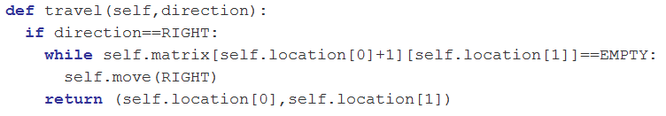 GREEN!
Now let’s just check the downward travel to assure ourselves that works. (A little extra work but not much)
RED!
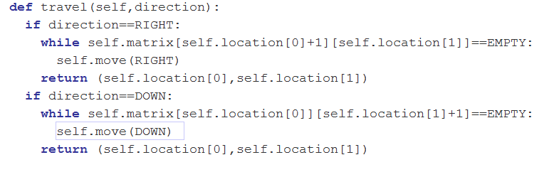 GREEN!
Complete the other two directions.
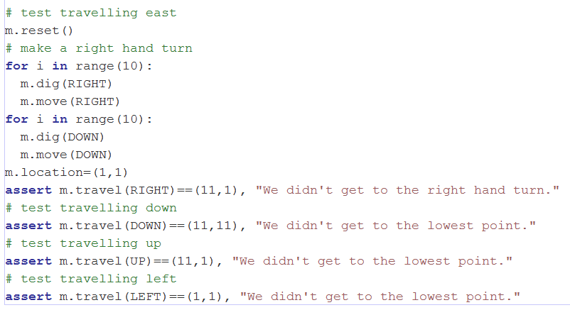RED!
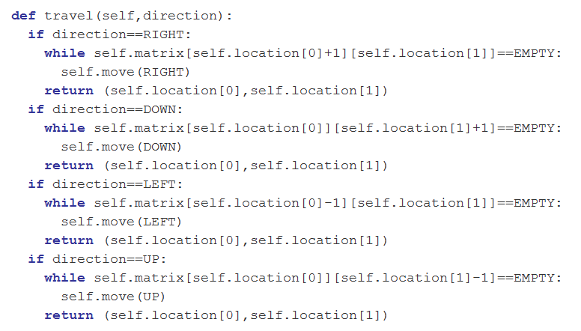GREEN!!
Now we have a way of getting to the turns.
For the second part of the algorithm, we need to determine which direction we can dig toward from the place where we stopped. So we should have a test for something that gives us our surroundings. Something you may not think about immediately is that we don't want to break through to the path to the gold as we fill the unused space. We also don't want to travel immediately next to another path making a path 2 blocks wide. So we check ahead and to the side as well.
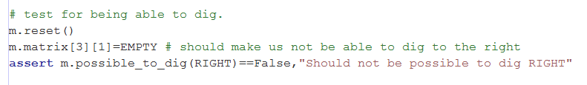
RED!
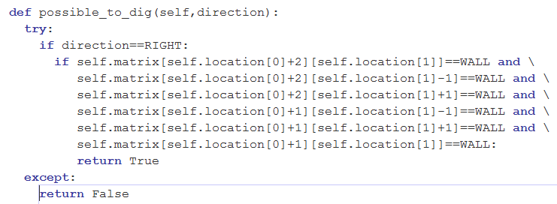
GREEN!
I skipped ahead and added all the code but leave it to the reader to finish the other directions.
We are at the point now where we can put it together and try to create make_fill(). This is a point where the testing is probably harder to implement than the algorithm. It's best to just view the results for now.
If we start from a reset condition and call make_fill(), we should see the whole maze filled with paths that never reach the border and never touch each other.
So our test starts out like this.
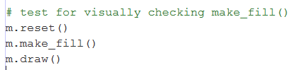
Of course we don't have make_fill created yet. Let's take our first crack at it with comments to try to help make it more clear.
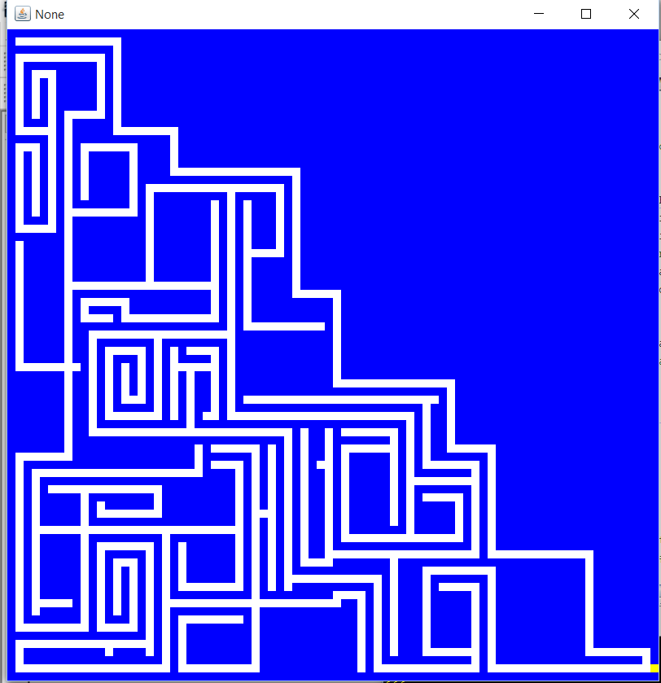

We want to start digging from each turn and stop before hitting the border or another empty square. The paths should be random in all four directions. No need to worry about which border we are heading for. Let’s call the method make_fill() and give it an initial direction. How can we check this function? One way is to make an artificial environment where we can predict the result. Consider the following image.  when we fill in at the first turn, the only choice is this. 
So let’s set up a test for that. Here’s the preparation.
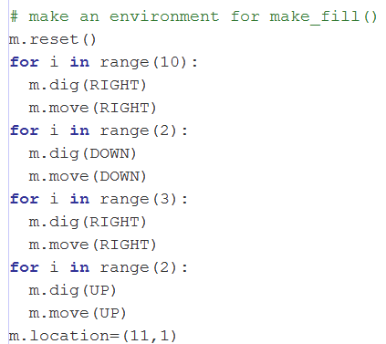This produces the first image above and places the location at the first turn.
Now after calling make_fill(RIGHT) we should get the second image.
The test just adds two more lines.
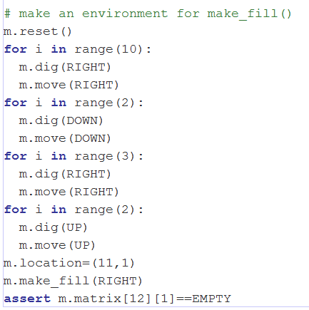Of course there is no make_fill yet. So fix that.

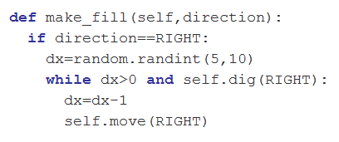GREEN!

This is just one test for location 12,1. That’s not enough to have confidence in the result. Check that (13,1) is still a wall.
and now we see it’s not quite right!
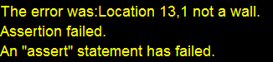
At this point it’s a good idea to just take a look at the maze and see what we have. You can type m.draw() into the command area to find out what the maze looks like.
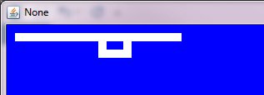 It appears that we went through and dug farther than we wanted. Debugging time! Let’s take another look at the code for make_fill().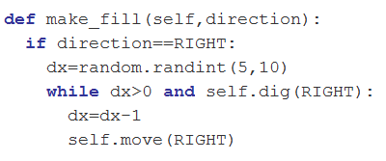Our while statement is true if dig returns true and dx is still not reduced to 0. Dig returns true if it succeeds. It should not have succeeded when we got to the empty square. We never checked that in our tests! Let’s add that test back where we were testing dig in the first place.
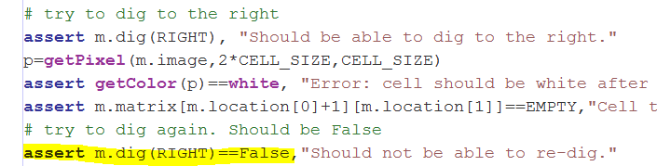 and now we see 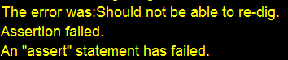
Now we need to look at dig to see why. It becomes obvious that we never check to see if the space is empty. Only if we hit a boundary. Let’s fix that. 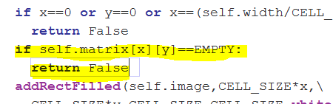 This fixed our new test for dig but we still have a failure with the make_fill test. Take another look at the matrix by typing m.draw().

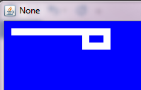 We don’t keep going past the empty space but we don’t want to break through either. Let’s just look ahead in dig and return false if it would break through to another path if we dug in that direction. Our test involves going to the right. We only change the code to deal with that situation first. Change the code in dig() to add this condition for the direction to the right.
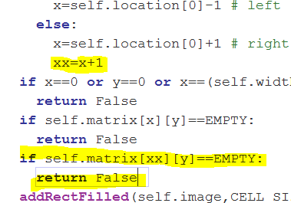 produces => 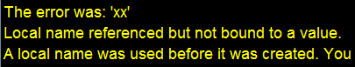 Oops! The variable xx is not set when we call dig in other tests for other directions. Easy to fix.
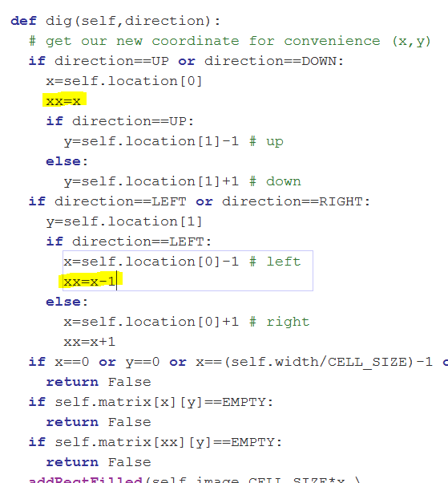 Now we are GREEN. Look at the maze again to verify we are ok.
 Let’s try an initial setup like this now. 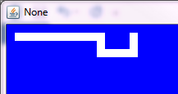 extending the space by 1. Now we want (13,1) to be empty and (14,1) to be a wall after we fill the space. Add this to your tests.
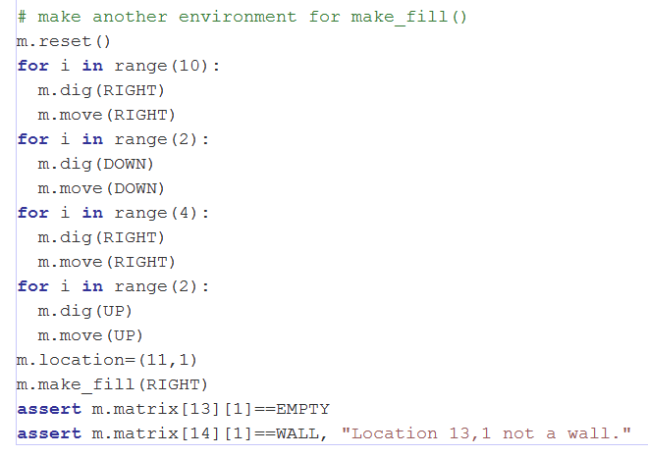It should pass. Nice to be able to skip the RED state on occasion! Let’s try this. 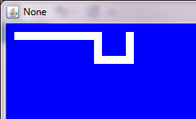 opening up the space a little more. We would like to have (13,2) empty now. 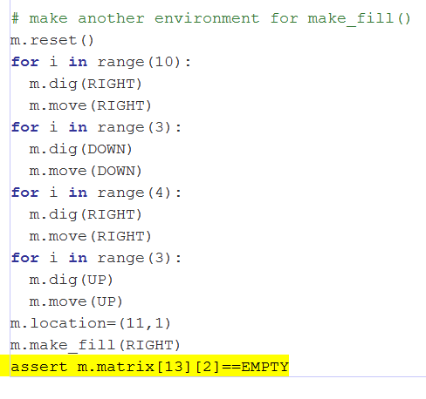Enter this test. RED! Check the maze by typing m.draw().

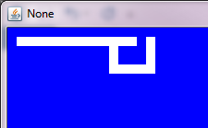 We are not heading downward yet to fill the space. This makes sense since we have only been dealing with the direction to the right. We need to add the other directions. We can sort-of see that after a while we will be filling smaller and smaller spaces each time we call make_fill(). This hints of recursion. Can we call make_fill from within make_fill to fill in the rest? I think so. We will make the terminating condition that we can’t dig in any direction. Otherwise we will call make_fill again with the new direction. Here’s my first crack at it.
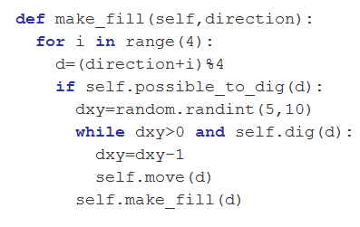 Notice I created a new function called possible_to_dig(). Here it is.
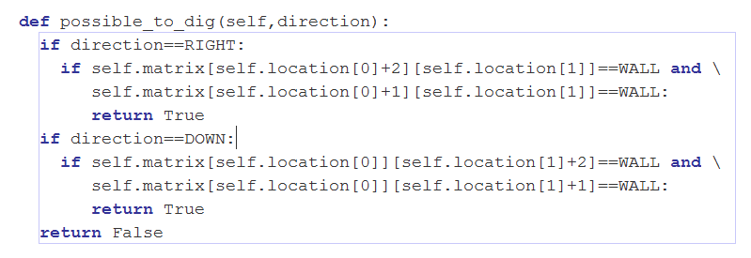Remember, I only put in code I need. We are not yet dealing with LEFT and UP. Let’s look at the maze now. 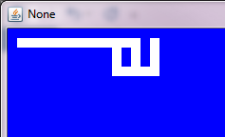 Looks like we broke through another wall. We aren’t testing enough. Add another test.
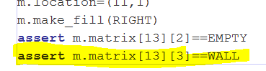 RED CONDITION!
Time to complete the code changes we started in dig. 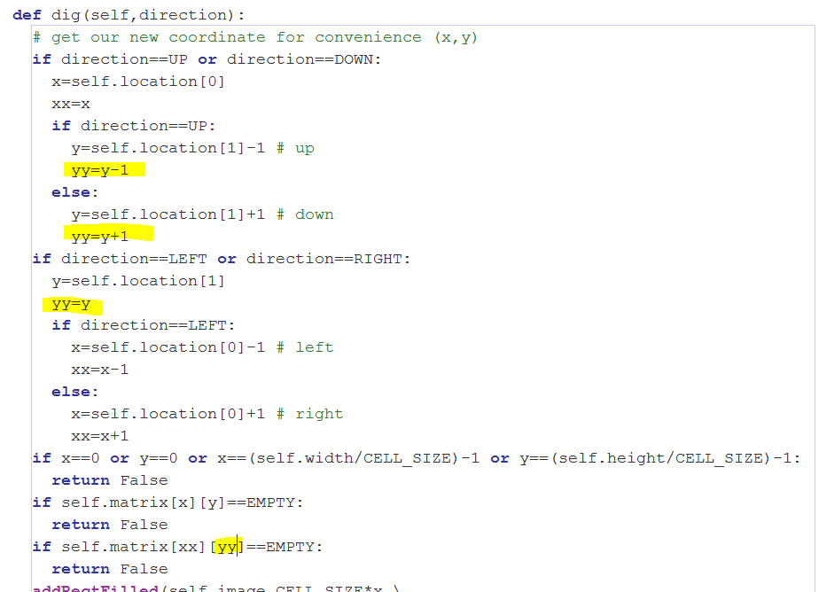 GREEN!
Look at the maze.  Looks good.

